POPBOX
Product Hardware Requirements Specification

Version： | V1.0.1 | No： | TH-TL-POP-10
Security level： | A+ | Department/Project： | Product department
Product： | POPBOX | Subsystem：

About the book
Book overview
This book is the blockchain project of POPCHAIN Foundation - POPCHAIN hardware terminal-POPBOX product hardware requirements specification.
POPCHAIN Foundation provides software and hardware design and implementation solutions for the project. The POPCHAIN Foundation has the final right to modify and interpret this document and program.

Contents
About the book 2
I. Introduction 4
1. Purpose 4
2. Scope 4
II. User role description 5
III. Product Overview 6
1. General process description 6
2. Architecture diagram 6
3. Main function description 7
IV. Product function requirements 8
1. Physical architecture and business process 8
2. Appearance function segmentation and definition 8
V. Other non-functional product requirements 10
1. Configuration requirements 10
2. Product application environment 10
3. Detailed hardware and structure requirements table 10
4. Other Requirements 11
VI. Risk Analysis 13

Introduction
This document, as a product development portal, can be used as a requirement document for internal hardware development, provide development direction and guidelines for the next product design, and provide basis and standard for product testing and acceptance. The overall product design and hardware design documentation are subject to the requirements described in this document.

Purpose
The purpose of this document is primarily to clarify the requirements for hardware development.

Scope
The main readers of this document are project managers, APP and server software developers, and hardware-related staff.

User role description
User role | User description
Ordinary user | POPBOX purchasers and users

Product Overview
This product is mainly used for Korean users, providing users with content viewing/sharing, private cloud disk, mobile screen, external screen display, Token management, mining, etc.

General process description
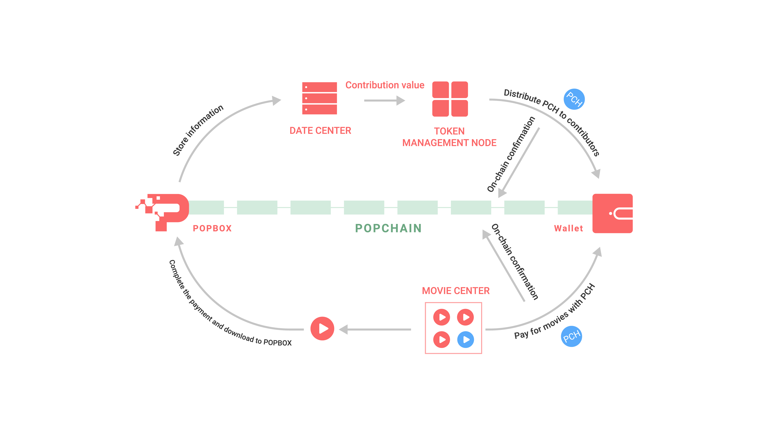
[General process descriotion]

Architecture diagram
The whole product architecture adopts the central server and client structure, and the POPBOX is used as a client for the end user. The central server controls all POPBOXes and provides various services (Token management, content management, etc.). The POPBOX can access locally saved content and content on other POPBOXes through the server, and each POPBOX is shared and accessed through P2P authorization (Note: this function is not implemented in the first phase). As shown below:
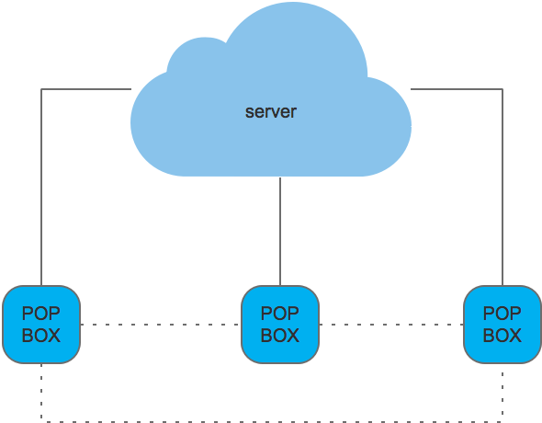
[Architecture diagram]

Main function description
The main functional modules are as follows
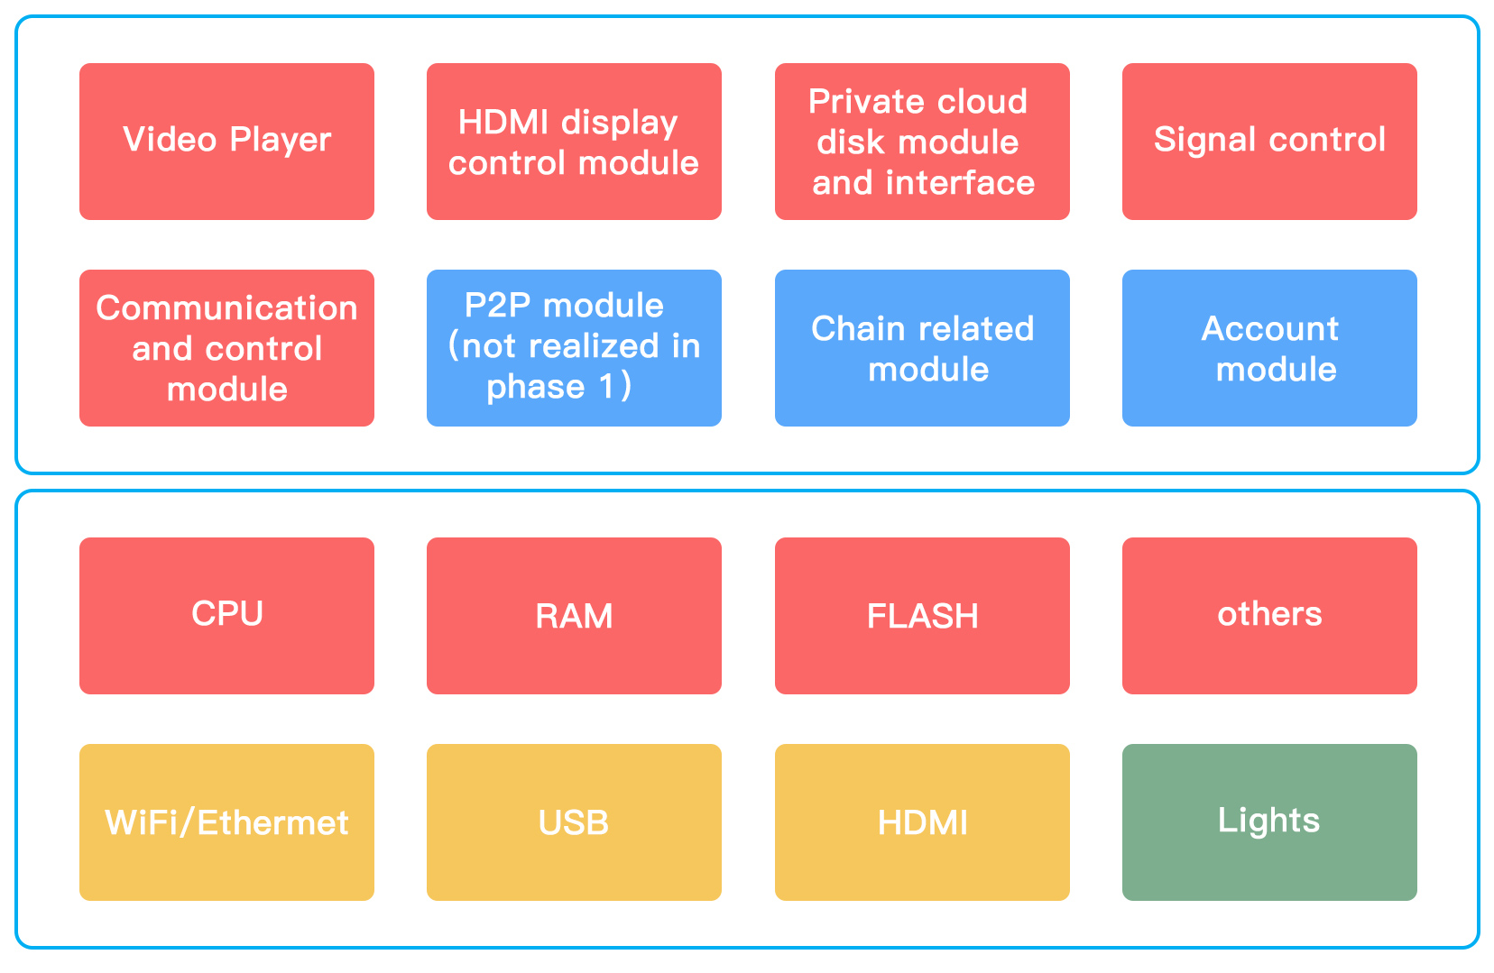
[Main function description]

Product function requirements

Physical architecture and business process
The physical architecture is shown below
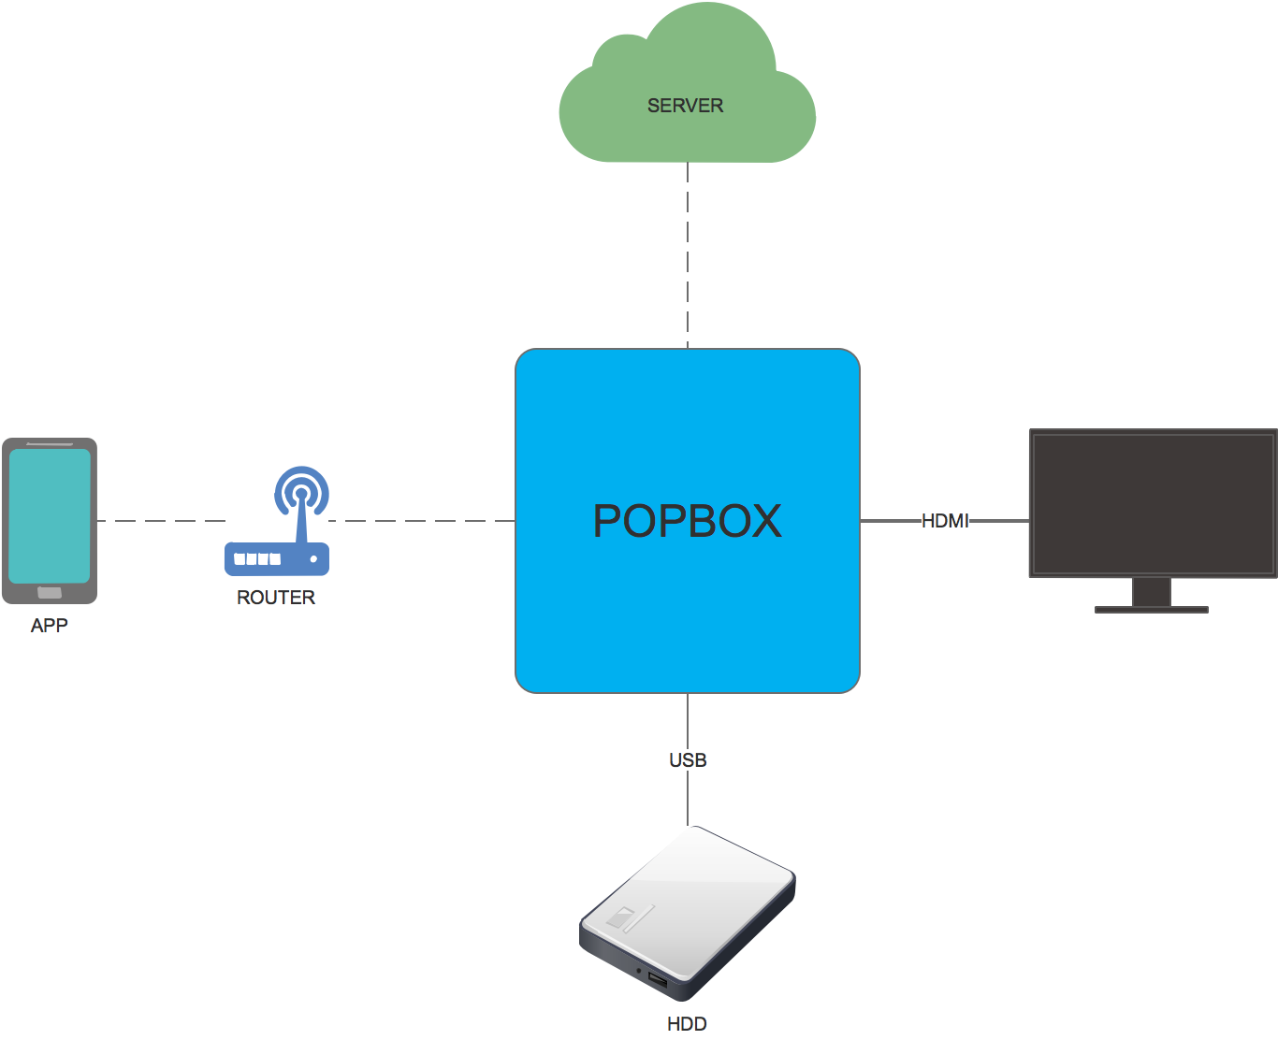
[Physical architecture and business process]

Business process：
- USB：Private cloud interface. Through USB, an external hard disk can be used as a private cloud disk to manage the storage of video, text, etc.
- HDMI：An external display interface through which an external 4K display image is displayed.
- APP：Through APP, the POPBOX mining revenue and the content of the corresponding user account can be managed, including private cloud disk management and content management.
- Server: See the server related documentation.

Appearance function segmentation and definition
- Ethernet interface :1 standard RJ45 interface
- Power socket: 1
- USB interface: 1 USB 2.0 interface
- HDMI interface: 1
- Indicators: 3, as defined below
- Power indicator: When the power is turned on, the red light is always on; when the power is not turned on, it is always dark.
- Network signal indicator: it flashes 2 times 1s in blue during the connection process, and it is always bright blue after the connection. If the connection fails, it shows bright red.
- Hard disk mount indicator: the mount completed is steady blue, and the failed mount is red.

Other non-functional product requirements

Configuration requirements
- CPU: Main frequency is no less than 2GHz/dual core
- RAM：Not less than 1GB, DDR3
- WiFi：Support 2.4G with Bluetooth module
- Ethernet: no less than 100M
- USB: At least 1 USB2.0 interface, the load capacity not lower than 500mA
- HDMI：At least 1 HDMI 2.0 interface with 4K 30fps output
- Power supply: Support Korean specifications and meet KC certification requirements

Product application environment
- Use environment: indoor scenes such as homes and offices
- Market positioning: Korea's exclusive supply
- Working temperature: 0~50 degrees, humidity: 10%~90% (non-condensing)
- Storage temperature: -20~60 degrees, humidity: 5%~95% (non-condensing)

Detailed hardware and structure requirements table
Hardware configuration
CPU | Hi3798M V200:Quad-Core Cortex-A53 CPU up to 2GHz,Penta-Core ARM Mali-450 up to 750MHz
RAM | Support dual channel 32-bit DDR3-2133， 1GB DDR3-1600
Memory storage | Support JEDEC eMMC5.0,product planning eMMC5.0 8bit ,Data width
Wifi/ Bluetooth | BT4.0 Integrated Combo Module  AP6212 802.11a/b/g/n 2.4G single admission；BT4.0
USB | A USB2.0 interface with a load capacity of no less than 500mA, support common hard disks
HDMI | HDMI2.0 Output interface, support 4K 60fps
Ethernet | 100/1000M Network port
Power interface | Outlet，2.0mm of the diameter of pin  Power socket, 2.0mm diameter pin, 6.0mm aperture
Switch | Power Off Self-locking switch, press lock Power On, unlock popup Power Off
Serial port | Board reserved 4Pin socket for pre-development and debugging. No post-production after mass production
System power supply | DCDC+LDO mode
Mainboard | No：1； Layer：4 ； Size: To be determined according to the appearance size
Power Adapter | DC12V-1A Wall Plug，Korean specifications, meet KC certification requirements
Overall power consumption | The maximum power consumption of the whole machine is not higher than 10W, and the standby power consumption is not required
Cooling solution | If necessary, heat sink, thermal pad, graphite sheet are allocated according to requirement
Back plate configuration
Padded back panel | Stroke self-locking switch, power socket, RJ45 network port socket, HDMI socket, USB2.0 socket
Front panel configuration
1 power indicator light; 1 WIFI signal light; 1 hard disk mount light

Other Requirements
Structure appearance
External view | To be determined
Colour | Black
Material | ABS plastic
Marking | Design according to customer
Size | To be determined
Appendix
Power adapter | 1
User manual | 1
Warranty card | 1
Barcode | 1
Cable | 1
Packaging
Inner box | The packaging, the inner box label, the inner box pattern and color, the inner box size, and the inner box weight are to be determined.
Outer box | The packaging, the outer box label, the outer box pattern and color, the outer box size, and the outer box weight are to be determined.
Security certificate
KC
Certification standards
Meet Korea's KC certification requirements

Risk Analysis
Risk | Possibility | Severity | Strategy | Responsiveness
Undetermined appearance leads to construction delay | 100% | Severe | Determine the appearance with the customer as soon as possible | Strong
Undetermined suppliers leads to construction delay | 100% | Severe | Coordinate customers to identify suppliers as soon as possible | Strong

